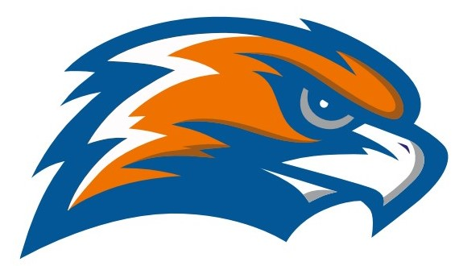

| **GARRETT MORGAN SOCCER 2021** |
| --- |

Head Coach Sean Law Assistant Coach Chad Meyers

Athletic Director Jennifer Smith

Principal GMSEI Quenton Davis

Principal GMSLI Anshawn Ivery – Administrator for Athletics

| **DATE** | **TIME** | **VISITOR** | **HOME** | **SITE** |
| --- | --- | --- | --- | --- |
| **Tuesday**  **8/24** | **4:00** | **Garrett Morgan** | **Lincoln West** | [**Collinwood Athletic Complex**](https://goo.gl/maps/PwUGE42TmPWqsFwXA) |
| **Thursday**  **8/26** | **4:00** | **Garrett Morgan** | **John Hay** | [**Collinwood Athletic Complex**](https://goo.gl/maps/PwUGE42TmPWqsFwXA) |
| **Monday**  **8/30** | **5:00** | **Garrett Morgan** | **Brooklyn** | [**Brooklyn Memorial Stadium**](https://goo.gl/maps/dVTPUWbv27tGta6j7) |
| **Tuesday**  **8/31** | **4:00** | **Garrett Morgan** | **Campus International** | [**Michael Zone**](https://www.mapquest.com/us/oh/cleveland/44102/6301-lorain-ave) |
| **Thursday**  **9/2** | **4:00** | **Garrett Morgan** | **John Marshall** | [**John Marshall**](https://www.google.com/maps/place/3952+W+140th+St,+Cleveland,+OH+44111/@41.446786,-81.7907535,17z/data=!4m2!3m1!1s0x8830edc2a7b7dbfd:0xadfdf9fc77740d49) |
| **Tuesday**  **9/7** | **4:00** | **Garrett Morgan** | **James F. Rhodes** | [**James F. Rhodes**](http://maps.google.com/maps?q=5100+Biddulph+Ave+Cleveland+OH+44144&hl=en&sll=41.563702,-81.592884&sspn=0.007128,0.050211&hnear=5100+Biddulph+Ave,+Cleveland,+Ohio+44144&t=m&z=14) |
| **Thursday**  **9/9** | **4:00** | **Garrett Morgan** | **Bard** | [**Michael Zone**](https://www.mapquest.com/us/oh/cleveland/44102/6301-lorain-ave) |
| **Tuesday**  **9/14** | **4:00** | **Garrett Morgan** | **Max Hayes** | [**Michael Zone**](https://www.mapquest.com/us/oh/cleveland/44102/6301-lorain-ave) |
| **Friday**  **9/17** | **5:00** | **Garrett Morgan** | **Bard**  **(independent)** | [**Michael Zone**](https://www.mapquest.com/us/oh/cleveland/44102/6301-lorain-ave) |
| **Thursday**  **10/14** | **4:00** | **Garrett Morgan** | **John Marshall (independent)** | [**John Marshall**](https://www.google.com/maps/place/3952+W+140th+St,+Cleveland,+OH+44111/@41.446786,-81.7907535,17z/data=!4m2!3m1!1s0x8830edc2a7b7dbfd:0xadfdf9fc77740d49) |

**SENATE PLAYOFFS - Tuesday Sep 21, 2021**

1st SEED VS 4th SEED @ John Marshall 4:00 pm

2nd SEED VS 3rd SEED @ Rhodes 4:00 pm

**SENATE CHAMPIONSHIP - Thursday September 23**

Collinwood Athletic Complex 4:00 pm

**OHSAA SECTIONALS - October 18 - 23 TBA**

**Senate Athletic League**

**Bard Garrett Morgan James F. Rhodes John Marshall**

**Campus Int. John Hay Lincoln West Max Hayes**